Exercise 1 :
First, we will create a new hard disk of 5GB for the virtual machine:

We select the setting Storage:
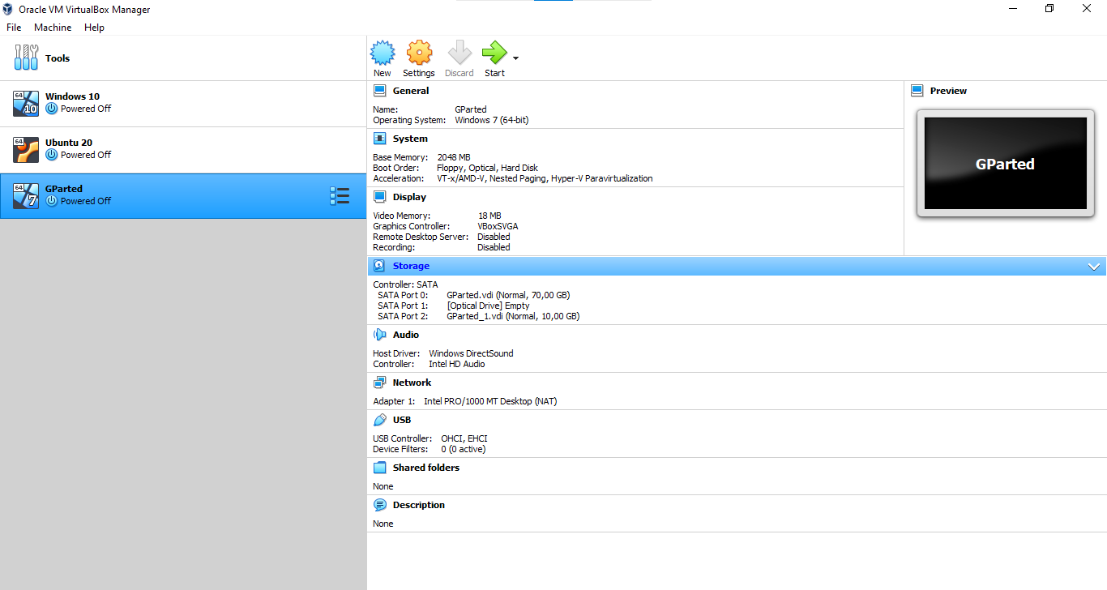

On the first option, Controller: SATA, you have to choose the option Add Hard Disk:
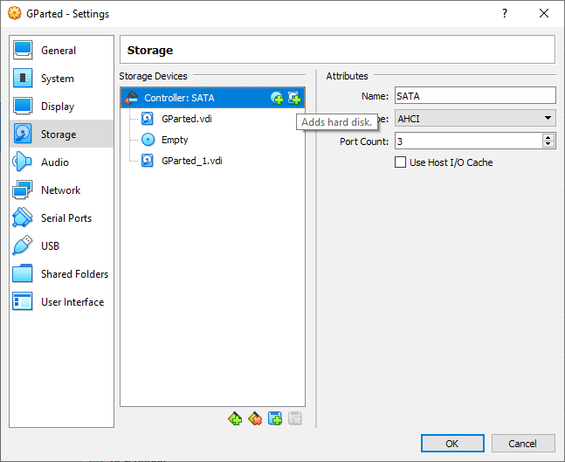

You will see the next screen on you machine, where you will select the option Create:
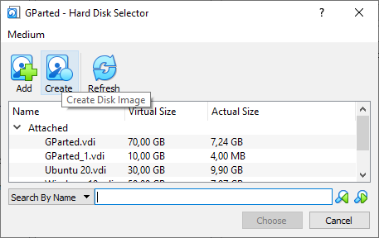

You choose the option VHD; then Dynamically allocated and then next:
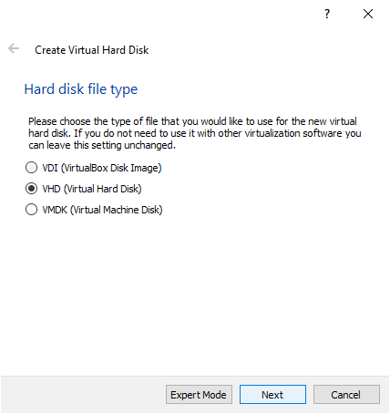
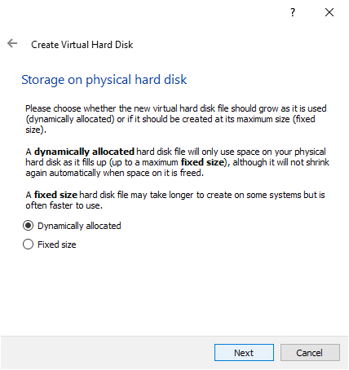

You select the size of your disk (5 GB) and finally Create:
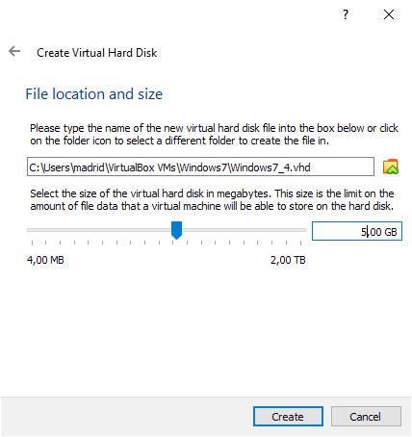

Now, we are ready to create the partitions required:
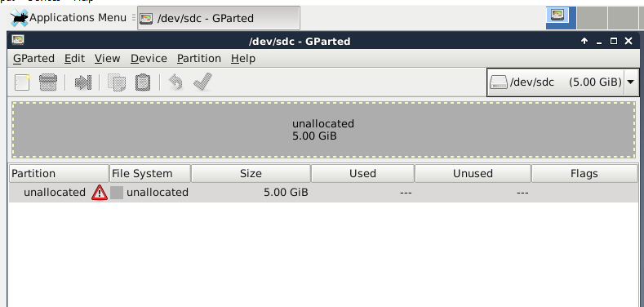

And then the option Device (inside the Gparted Window), and finally Create Partition Table, remember to select the MSDOS partition type:
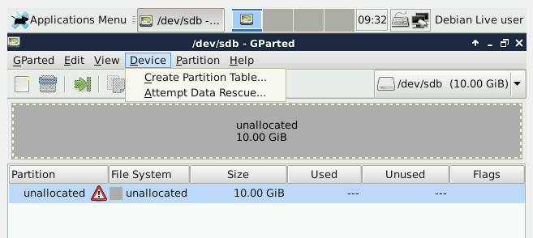
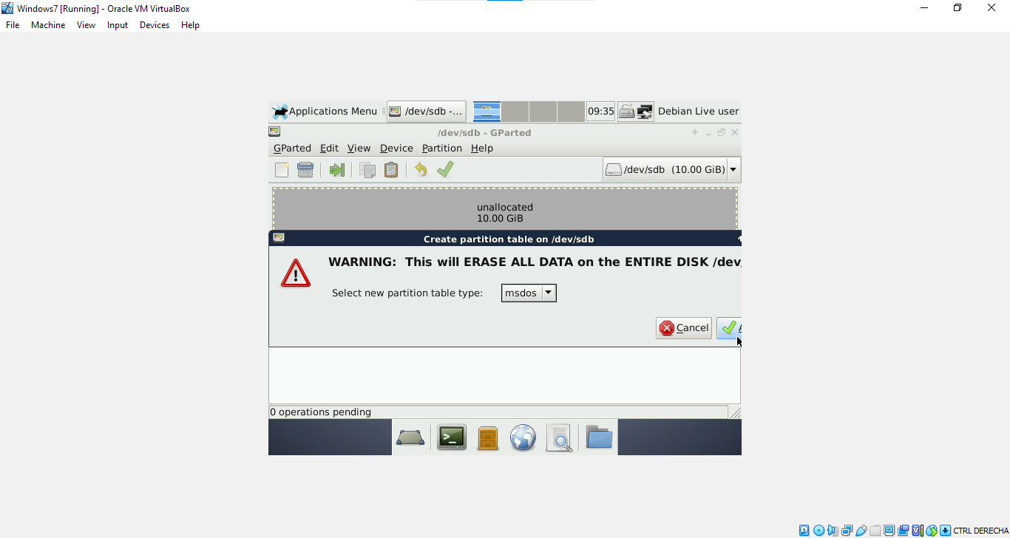

Now you will create a FAT primary partition of 1GB called ONE:
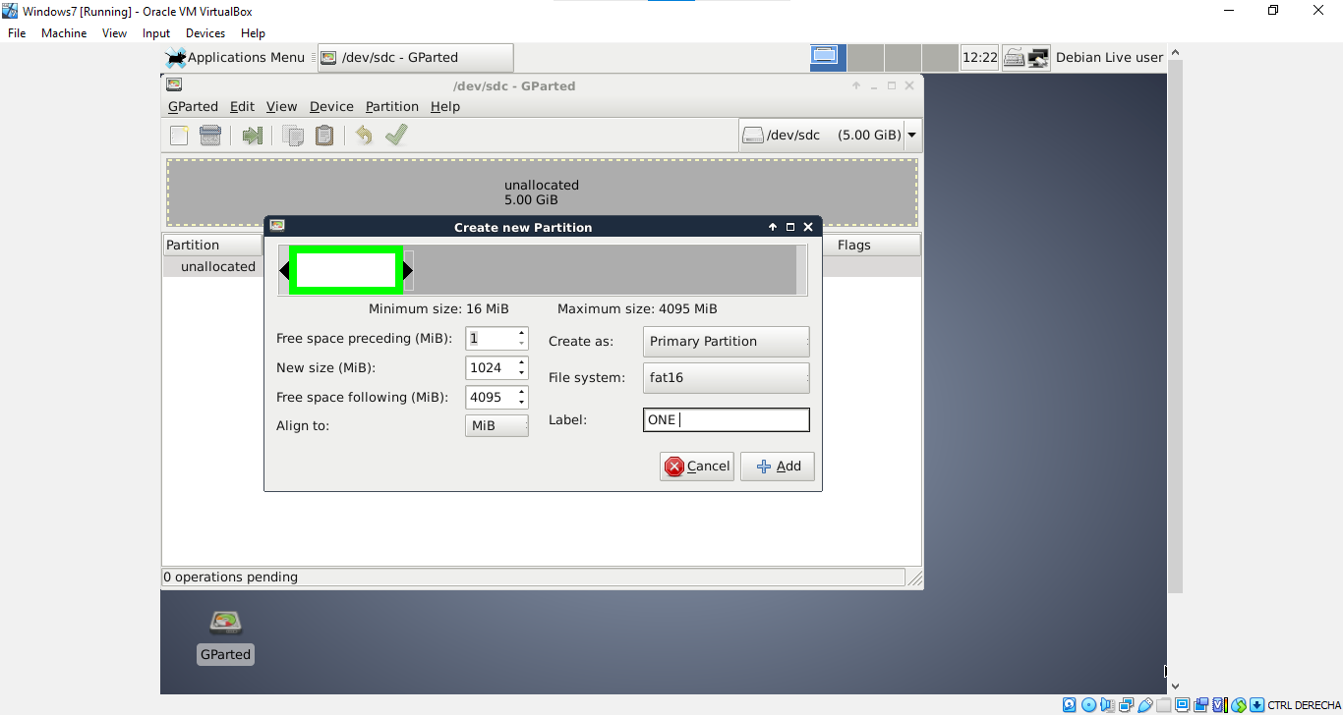

Now a FAT32 primary partition of 1GB called THREE:
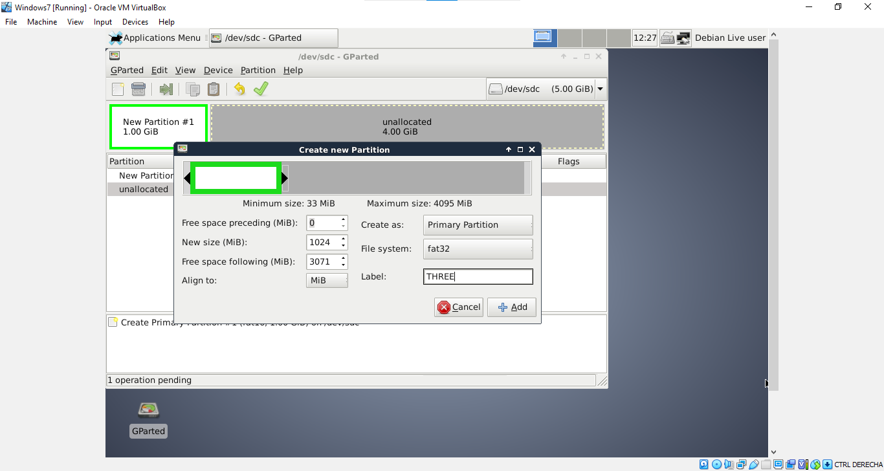

Now an extended partition of 2 GB:
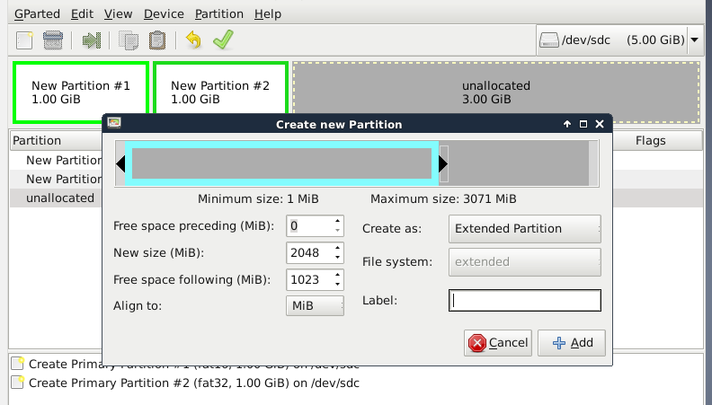

A logical partition of 1GB called FOUR:
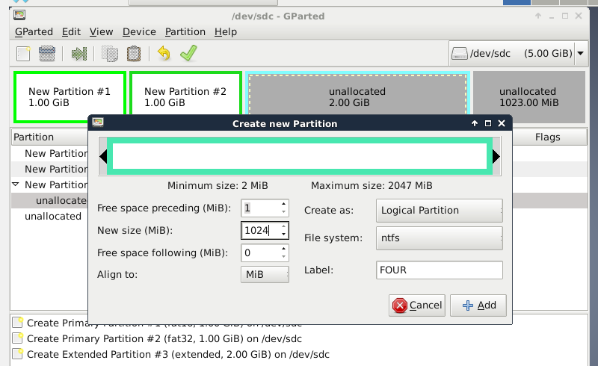

A logical partition of 512MB called SIX:
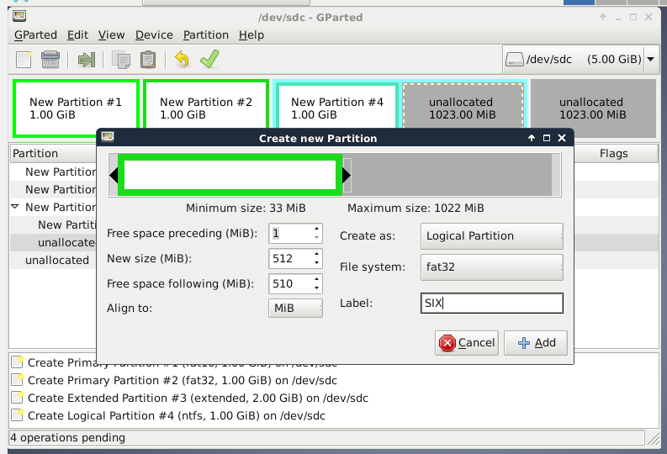

Now an ext4 primary partition of 1GB:
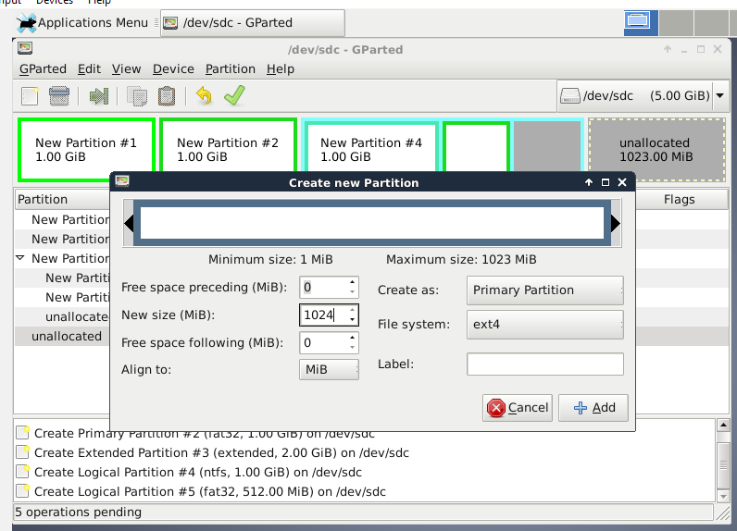

Remember to Apply the pending operations that you just have done with the “swoosh” green icon:
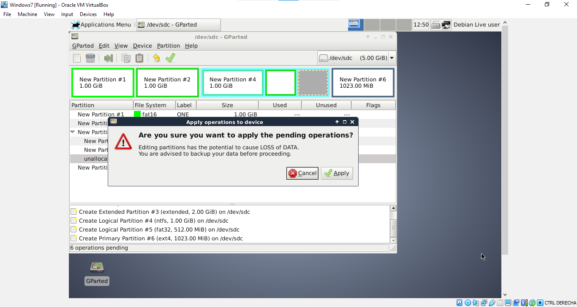

Your screen will look like this:
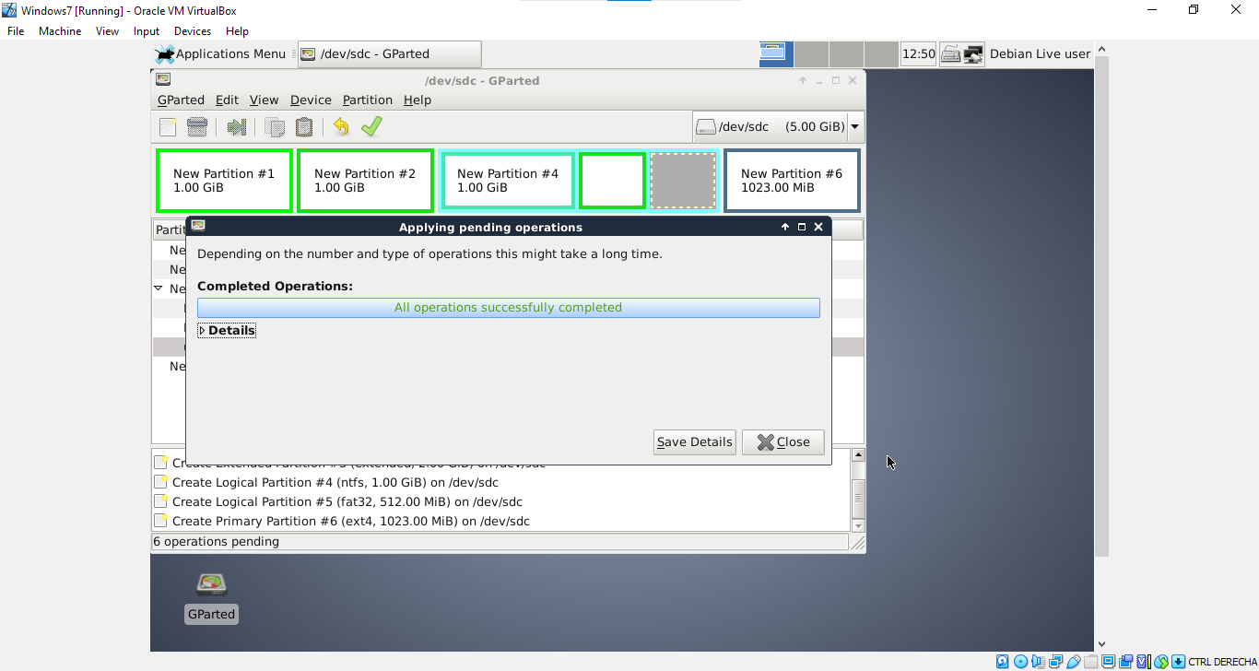

Do not forget to shut down the VM:
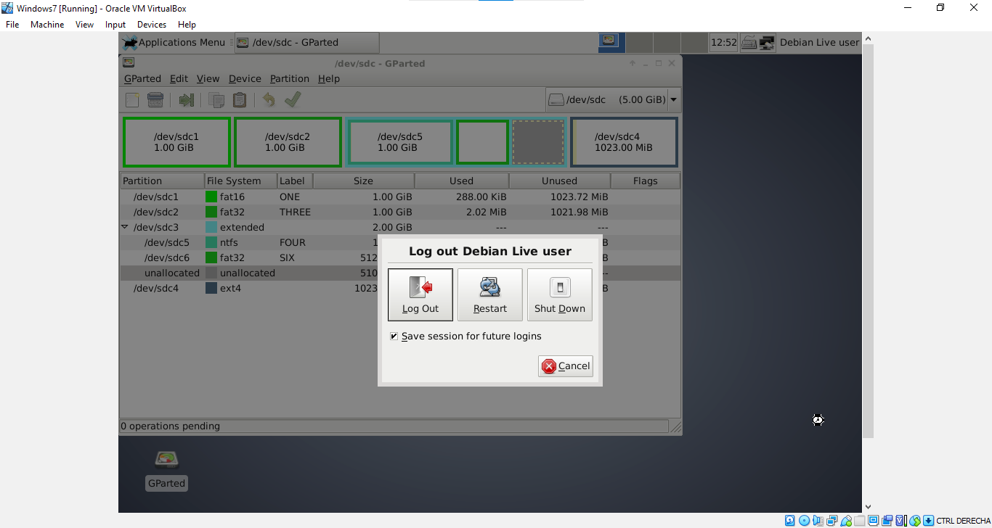

And finally start on the VM again and go to the Disk Management menu, you will see this on you screen:
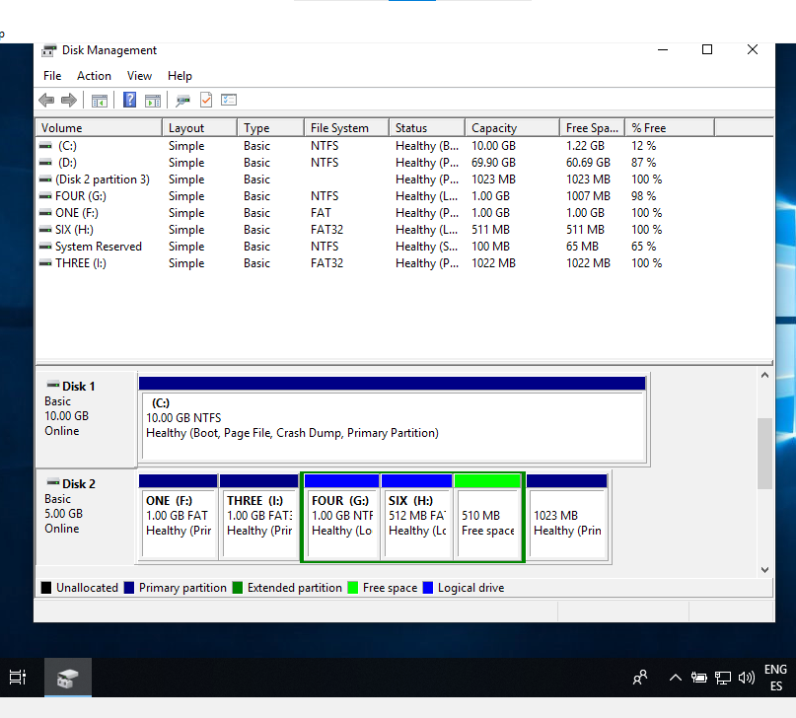

Now answer the following questions
1. How does GParted name the new hard disk?
Disk 2
2. List all the partitions you have created, indicating type and file system.
1) A FAT primary partition of 1GB called ONE
2) A FAT32 primary partition of 1GB called THREE
3) An extended partition of 2 GB
4) A logical partition of 1GB called FOUR
5) A logical partition of 512MB called SIX
6) An ext4 primary partition of 1GB

